Protein Structure Prediction – Bovine Cytochrome B (5)

**OBJECTIVE**: To predict the three-dimensional structure of the **Bovine Cytochrome B (5)** protein using its amino acid sequence. Understanding the structure helps reveal functional regions, contributing to research in biochemistry, molecular biology, and drug development.

**TOOLS REQUIRED**: **SWISS-MODEL** – for homology-based 3D structure prediction **and PyMOL** – for molecular visualization and analysis

**PROCCEDURE:**

1. **Selection of Protein: The** protein I chosen is **Bovine Cytochrome B (5) having PDB** ID: **pdb_00001cyo. FASTA** format is retrieved from public databases.
2. **Structure Prediction**: Sequence submitted to **SWISS-MODEL**. Homology modelling performed based on existing templates. The predicted structure was obtained and further analysed.
3. **Model Validation**: The model was validated using standard quality parameters:

| **✅ Parameter** | **✅ Requirement** | **✅ Result** |
| --- | --- | --- |
| Sequence Identity | > 50% | 100% |
| GMQE | Close to 1 | 0.83 |
| Coverage | > 70% | 100% |
| Ramachandran Plot | > 90% residues allowed | 98.81% |
| Z-score | Close to 0 | -0.13 |

1. **Structure Visualization**

* The 3D model was visualized using **PyMOL**.

1. Conclusion: A high-confidence 3D structure of **Bovine Cytochrome B (5)** was successfully modelled and validated, offering valuable insights into its functional regions and structural integrity. This project builds a foundation for future research in molecular biology, enzyme mechanisms, and drug design.

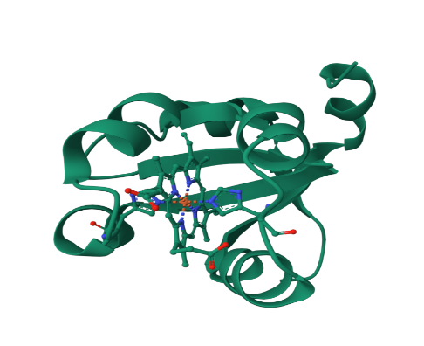

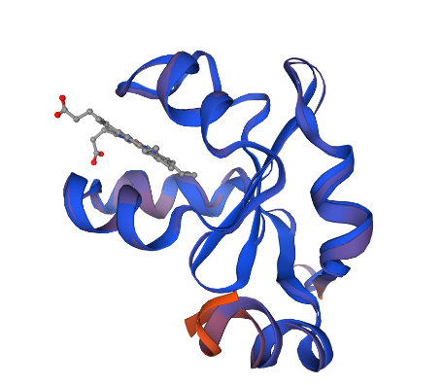

PARAMETERS SELECTED FOR THE MODEL

SWISS MODEL STRUCTURE

PDB STRUCTURE

